## Turn-on Internet on Dev Cloud System

By default, the commissioned VM Cloud machine has no internet access. In order to turn on the Internet, Open Internet Explorer 🡪 Click Settings 🡪 Tab to Internet Options and Click LAN Settings:

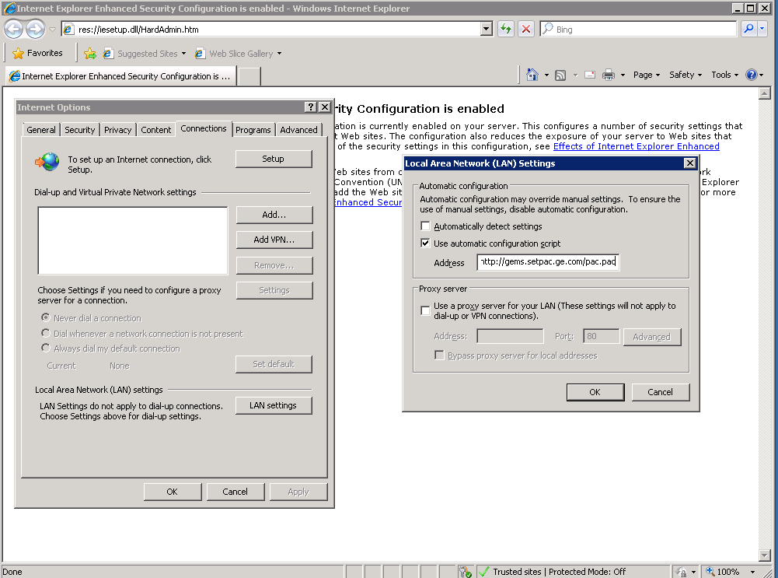

Figure Setup LAN Settings

In the Local Area Network (LAN) Settings Dialog, check Use automatic configuration script and provide Address: <http://gems.setpac.ge.com/pac.pac>

## Configure Internet Explorer Enhanced Security (IE ESC) Settings

By default, Internet Explorer Enhanced Security Settings are turned-on on VM Cloud machine. These security settings inhibit seamless access to the internet unless all the requesteed domains are configured part of the IE ESC settings.

In order to turn-off IE ESC settings:

### Open Server Manager

First, open Server Manager. To open Server Manager, please click Start Menu 🡪 Administrative Tools 🡪 Server Manager.

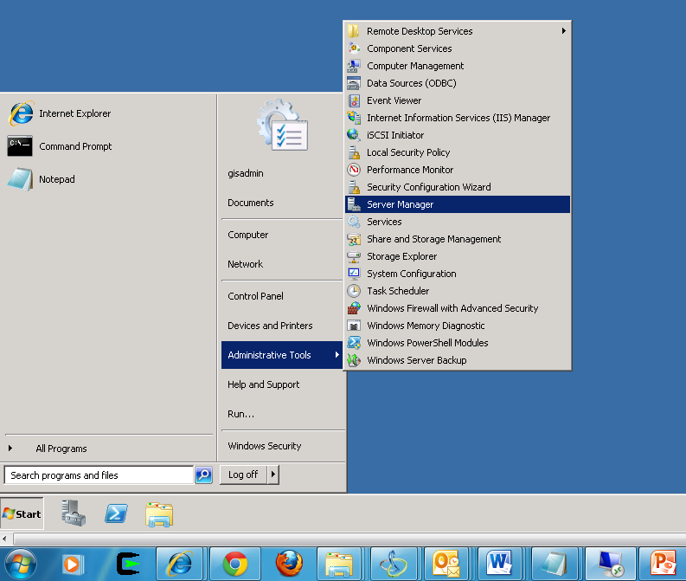

Figure : Open Server Manager

### Turn-off Enhanced Security

Under Security Information Panel, clicn IE ESC. This will result display of Internet Explorer Enhanced Security Configuration Window.

Turn off Administrator and Users security.

